# image1.png

**THE INTERNSHIP TEST**

***Time: 60 minutes***

**1.** Identify the missing square

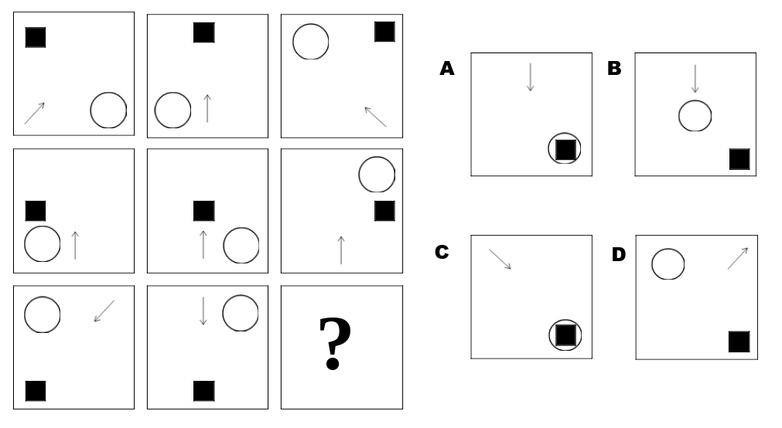

**2.**

1 + 4 = 5

2 + 5 = 12

3 + 6 = 21

8 + 11 = ?

**3.** Find the number which replaces the question mark.

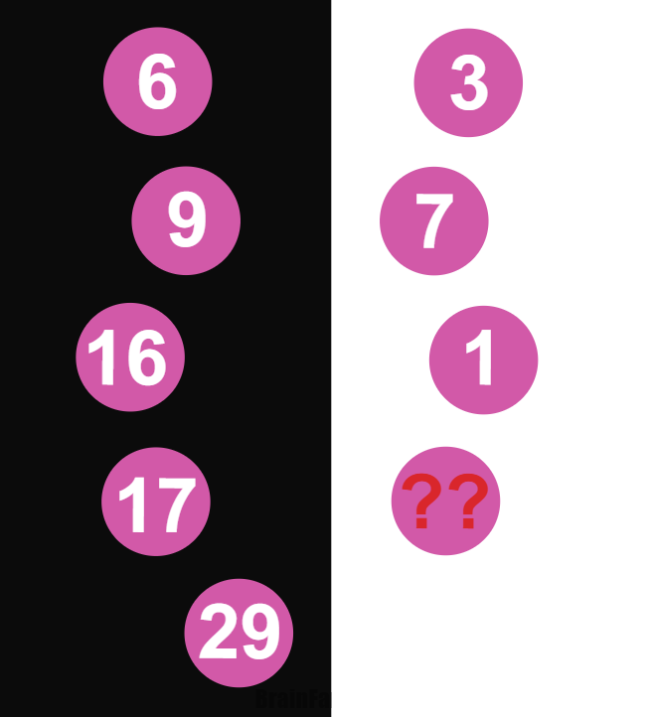

**4.**

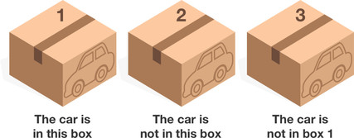

There are 3 boxes, exactly one of which has a car. You can keep the car if you pick the correct box!

On each box there is a statement**, exactly one** of which is true.

Box 1: The car is in this box.

Box 2: The car is not in this box.

Box 3: The car is not in box 1.

Which box has the car?

A. Box 1

B. Box 2

C. Box 3

**5.**

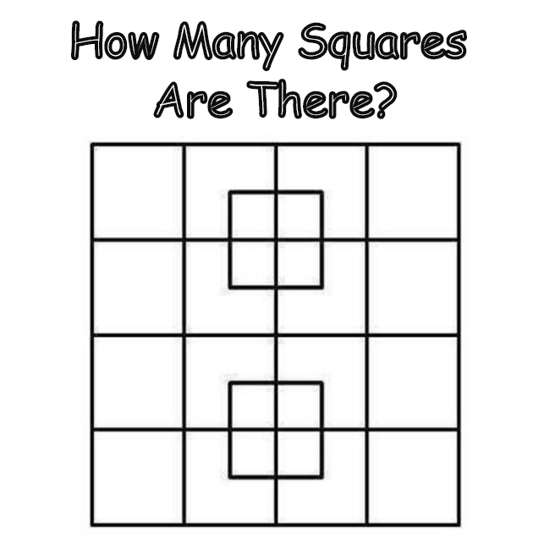

**6.** What is the output?

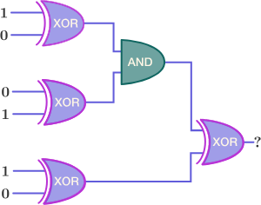

A. 0

B. 1

**7.** Assume that you are playing a Tic-tac-toe game with an opponent. You are playing as while your opponent plays as .

The game is played as follows:

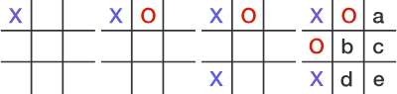

Find all the possible grid tiles where you can put an -mark that will help you guarantee yourself a win under best play.

A. a

B. b

C. c

D. d

E. e

F. Either a or b

G. Either b or e

**8.** What is the size of ‘int’?

[A. 2](javascript:void(0);)

[B. 4](javascript:void(0);)

[C. 8](javascript:void(0);)

D. Compiler dependent

**9.** Which library function can convert an unsigned long to a string?

A. ltoa()

B. ultoa()

C. system()

D. unsigned long can’t be converted to a string

**10.** What will be the output of the program ?

#include<stdio.h>

int main()

{

struct { int x;} var = {5}, *p = &var;

printf("%d %d %d", var.x, p->x, (*p).x);

return 0;

}

A. 5 5 5

B. 5 5 garbage value

C. 5 5 0

D. Compile error

**11**. Which of the following services use TCP?

1. DHCP 2. SMTP 3. HTTP 4. TFTP 5. FTP

A. 1 and 2

B. 2, 3 and 5

C. 1, 2 and 4

D. 1, 3 and 4.

**12.** Which type of constructor can’t have a return type?

A. Default

B. Parameterized

C. Copy

D. Constructors don’t have a return type

**13**. To sort many large object or structures, it would be most efficient to:

A. Place them in an array and sort the array

B. Place them in a linked list and sort the linked list

C. Place pointers to them in an array and sort the array

D. Place reference to them in and array an sort the array

**14.** When using the SQL INSERT statement:

A. rows can be modified according to criteria only.

B. rows cannot be copied in mass from one table to another only.

C. rows can be inserted into a table only one at a time only.

D. rows can either be inserted into a table one at a time or in groups.

**15.** (SQL) To sort the results of a query use:

A. SORT BY

B. GROUP BY

C. ORDER BY

D. None of the above is correct

**16**. How many instances of an abstract class can be created?

A. 1

B. 5

C. 13

D. 0

**17**. Structured Query Language (SQL) is an internationally recognized standard language that is understood by all commercial database management system products.

A. True

B. False

**18.** How many swaps are required to sort the given array using bubble sort - {5, 1, 4, 2, 8}

A. 7

B. 4

C. 6

D. 5

**19.** In HTTP pipelining:

A. multiple HTTP requests are sent on a single TCP connection without waiting for the corresponding responses.

B. multiple HTTP requests can not be sent on a single TCP connection.

C. multiple HTTP requests are sent in a queue on a single TCP connection.

D. none of the mentioned.

**20**. Predict output of following program

#include<stdio.h>

int fun(int n)  
{  
 if (n ==5)

return n;

else return 2*fun(n+1);   
}

int main()  
{  
 printf(“%d ”, fun(2));

return 0;  
}

1. 4
2. 8
3. 16
4. 40
5. Runtime Error

Question: *How would you describle yourself? And what are your short-term job goals?*

***----------------- Thank you! ------------------***